**Top Trending Diary Dates**

**Events**

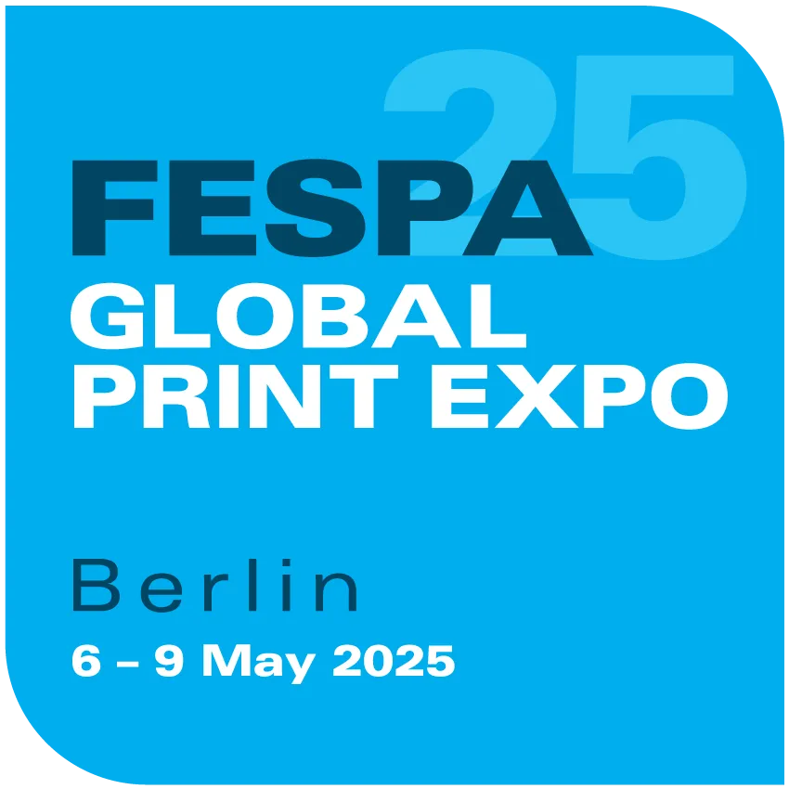



After a successful second co-location, both **Printwear & Promotion LIVE! and Sign & Digital UK** will return to the NEC in Birmingham in February 2026.

